**Front-End UI/UX Mini Project**

**Project Submission Template**

**1. Title Page**

* **Project Title**: "Dark Mode Personal Portfolio Website for Computer Science Professional"
* **Submitted By**:
  + ANURAG ETTA -246335
  + CHARAN SC-2460489
  + JESSE SUNIL-2460375
* **Course**: UI/UX Design Fundamentals
* **Instructor Name**: MR. Dhiraj
* **Institution**: CHRIST(Deemed to be University)
* **Date of Submission**: 11-08-25

**2. Abstract**

This project focuses on designing and developing a dark-themed personal portfolio website for a computer science professional using HTML5 and CSS3. The website features a cyberpunk-inspired color scheme with neon accents (#00ffcc and #ff00ff) against dark backgrounds, creating a modern, tech-focused aesthetic. The portfolio includes sections for personal introduction, resume, projects showcase, and contact information. Key features include smooth hover animations, glowing effects, and a responsive grid layout for project cards. The project demonstrates mastery of CSS transitions, box shadows, and dark UI design principles while maintaining excellent readability and user experience.

**3. Objectives**

* Design a modern dark-themed interface following contemporary UI/UX trends
* Implement a cohesive color scheme with neon accent colors for tech appeal
* Develop a fully responsive layout using semantic HTML5 and CSS3
* Create engaging hover effects and smooth transitions for enhanced interactivity
* Apply CSS Grid layout for project showcase with scalable card design
* Ensure optimal readability and contrast in dark mode design
* Demonstrate proficiency in CSS animations and visual effects
* Build a professional portfolio structure suitable for computer science careers

**4. Scope of the Project**

**Included:**

* Complete dark-themed personal portfolio website
* Pure HTML5 and CSS3 implementation (no external libraries)
* Responsive design optimized for desktop, tablet, and mobile devices
* Four main sections: About, Resume, Projects, Contact
* Interactive elements with hover effects and transitions
* Cyberpunk-inspired visual design with neon color accents
* Professional layout suitable for computer science portfolio

**Boundaries:**

* Static front-end implementation only
* No JavaScript functionality or backend integration
* Focus on visual design and CSS animation techniques
* Placeholder content for demonstration purposes
* No external font libraries or icon frameworks

**5. Tools & Technologies Used**

| **Tool/Technology** | **Purpose** |
| --- | --- |
| HTML5 | Semantic markup structure and content organization |
| CSS3 | Styling, animations, and responsive layout management |
| CSS Grid | Project cards layout and responsive design |
| CSS Flexbox | Navigation alignment and component positioning |
| CSS Transitions | Smooth hover effects and interactive animations |
| Box Shadow | Glowing effects and depth creation |
| Media Queries | Responsive breakpoints (implied for grid behavior) |
| VS Code | Development environment and code editing |
| Chrome DevTools | Testing, debugging, and responsive design validation |

**6. HTML Structure Overview**

* **Semantic Structure**: Clean HTML5 semantic elements including <header>, <nav>, <section>, and <footer>
* **Content Organization**: Logical sectioning with ID-based navigation:
  + Header with title and specialization
  + Horizontal navigation menu with smooth scroll anchors
  + About section with personal introduction
  + Resume section with qualifications and download button
  + Projects section with grid-based card layout
  + Contact section with contact information and email link
  + Footer with copyright and branding
* **Accessibility**: Proper heading hierarchy, semantic navigation, and descriptive anchor links
* **Navigation Structure**: Single-page application with anchor-based section jumping

**7. CSS Styling Strategy**

* **Architecture**: Embedded CSS within HTML head for simplified deployment
* **Design Philosophy**: Dark mode with high-contrast neon accents for modern tech aesthetic
* **Color System**:
  + Primary background: Deep blacks (#0d0d0d, #1a1a1a)
  + Accent colors: Cyan (#00ffcc) and Magenta (#ff00ff)
  + Text: Light gray (#e0e0e0) for optimal readability
* **Layout Techniques**:
  + CSS Grid for responsive project cards
  + Flexbox for navigation alignment
  + Centered content with max-width constraints
* **Interactive Design**:
  + Hover transitions on navigation and buttons
  + Scale transforms on project cards
  + Dynamic box-shadow effects for glowing appearance
* **Visual Effects**: Consistent border-radius, glowing shadows, and smooth animations

**8. Key Features**

| **Feature** | **Description** |
| --- | --- |
| Dark Mode Design | Complete dark theme with high contrast and neon accents |
| Neon Glow Effects | CSS box-shadow creating cyberpunk-style glowing elements |
| Interactive Hover States | Smooth transitions on navigation, buttons, and project cards |
| Responsive Grid Layout | Auto-fitting grid system for project showcase cards |
| Professional Structure | Clear sections for About, Resume, Projects, and Contact |
| Smooth Animations | CSS transitions for enhanced user experience |
| Tech-Focused Aesthetic | Color scheme and design appealing to computer science audience |
| Scalable Card Design | Project cards with hover effects and consistent styling |

**9. Challenges Faced & Solutions**

| **Challenge** | **Solution** |
| --- | --- |
| Maintaining readability in dark theme | Used high contrast ratios with light text (#e0e0e0) on dark backgrounds |
| Creating effective glow effects without overwhelming design | Applied subtle box-shadow with appropriate blur radius and color intensity |
| Balancing neon colors without creating visual fatigue | Limited accent colors to specific UI elements (borders, links, buttons) |
| Ensuring hover effects work across different devices | Used CSS transitions with appropriate timing and transform properties |
| Creating responsive grid without media queries | Utilized CSS Grid's auto-fit and minmax functions for natural responsiveness |
| Maintaining visual hierarchy in monochromatic scheme | Used color, size, and spacing variations to establish clear content hierarchy |

**10. Outcome**

* Successfully created a visually striking dark-themed portfolio that appeals to tech professionals
* Achieved seamless responsiveness using CSS Grid's auto-fitting capabilities
* Implemented smooth, engaging animations that enhance user experience without overwhelming content
* Developed a cohesive design system using a limited color palette effectively
* Created professional portfolio structure suitable for computer science career showcase
* Demonstrated advanced CSS techniques including transforms, transitions, and shadow effects
* Learned principles of dark UI design including contrast management and accent color usage
* Built understanding of how visual design can reflect professional identity and target audience

**11. Future Enhancements**

* **JavaScript Interactivity**: Add smooth scrolling navigation, dynamic content loading, and interactive project filters
* **Advanced Animations**: Implement CSS keyframe animations for page load effects and micro-interactions
* **Backend Integration**: Connect contact form functionality and resume download capabilities
* **Theme Switching**: Add light/dark mode toggle for user preference
* **Project Details**: Expand project cards with detailed modal views and live demo links
* **Performance Optimization**: Optimize CSS delivery and implement lazy loading
* **Advanced Visual Effects**: Add particle backgrounds, typing animations, and progressive reveal effects
* **Content Management**: Dynamic project loading and blog integration

**12. Sample Code**

**Dark Theme Color System and Base Styles**

body {

margin: 0;

font-family: Arial, sans-serif;

background-color: #0d0d0d;

color: #e0e0e0;

}

header {

background-color: #1a1a1a;

padding: 20px;

text-align: center;

border-bottom: 2px solid #00ffcc;

}

**Interactive Navigation with Hover Effects**

nav a {

color: #00ffcc;

text-decoration: none;

font-weight: bold;

transition: color 0.3s ease;

}

nav a:hover {

color: #ff00ff;

}

**Responsive Grid with Glowing Card Effects**

.grid {

display: grid;

grid-template-columns: repeat(auto-fit, minmax(200px, 1fr));

gap: 20px;

}

.card {

background-color: #1f1f1f;

padding: 15px;

border-radius: 10px;

box-shadow: 0 0 15px #ff00ff;

transition: transform 0.3s ease, box-shadow 0.3s ease;

}

.card:hover {

transform: scale(1.05);

box-shadow: 0 0 25px #00ffcc;

}

**13. Screenshots of Final Output**

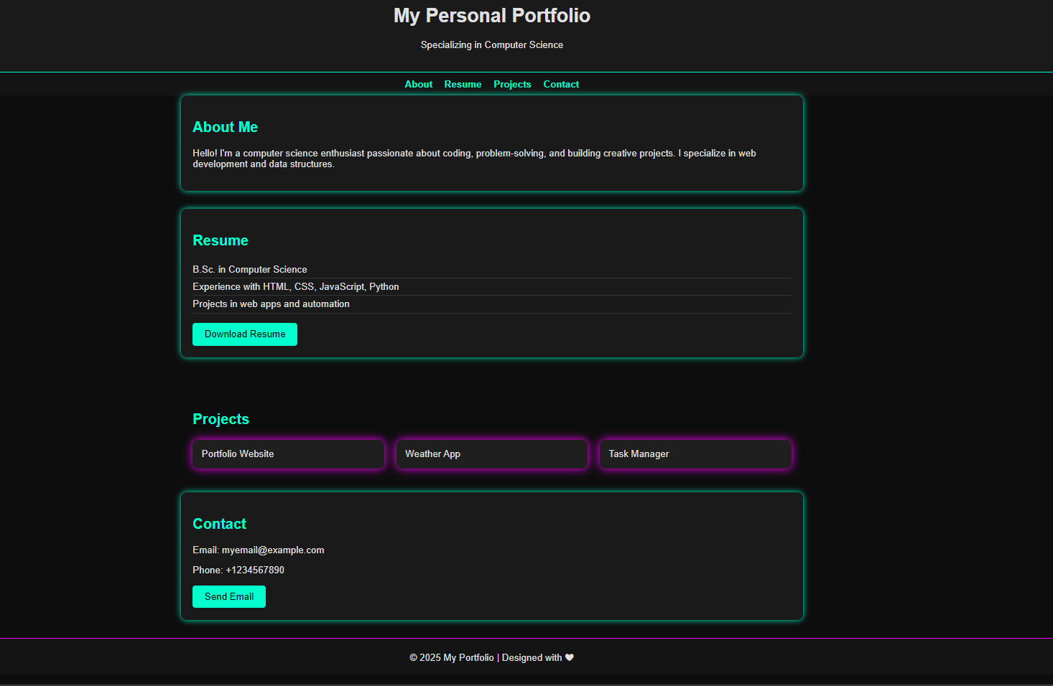

* **Desktop View**: Full dark theme with neon accents and complete layout
* **Mobile View**: Responsive grid adaptation and navigation stacking
* **Hover States**: Interactive elements showing color transitions and glow effects
* **Project Grid**: Close-up of responsive card layout with scaling effects
* **Navigation**: Demonstration of hover color changes and smooth transitions
* **Section Details**: Individual sections showing consistent dark theme application

**14. Conclusion**

This dark mode personal portfolio project successfully demonstrates advanced CSS styling techniques and modern dark UI design principles. The project showcases effective use of color psychology in web design, utilizing cyberpunk-inspired neon accents to create a tech-forward aesthetic appropriate for computer science professionals.

Through this implementation, I gained valuable experience in creating visually engaging dark interfaces while maintaining excellent readability and user experience. The project enhanced my understanding of CSS animations, hover effects, and responsive grid systems. The hands-on development of a complete dark-themed portfolio provided practical insights into color contrast management, visual hierarchy in monochromatic designs, and creating cohesive brand identity through consistent styling.

The final product demonstrates proficiency in modern CSS techniques including transforms, transitions, and advanced layout methods. This project serves as an excellent foundation for understanding how design choices can reflect professional identity and target audience preferences, particularly in the technology sector where dark themes are increasingly popular.

**15. References**

* L&T LMS: https://learn.lntedutech.com/Landing/MyCourse
* MDN Web Docs - CSS Grid Layout: https://developer.mozilla.org/en-US/docs/Web/CSS/CSS_Grid_Layout
* MDN Web Docs - CSS Transitions: https://developer.mozilla.org/en-US/docs/Web/CSS/CSS_Transitions
* CSS-Tricks - Box Shadow: https://css-tricks.com/almanac/properties/b/box-shadow/
* Material Design - Dark Theme Guidelines: https://material.io/design/color/dark-theme.html
* Web Content Accessibility Guidelines (WCAG) - Contrast Requirements: https://www.w3.org/WAI/WCAG21/Understanding/contrast-minimum.html